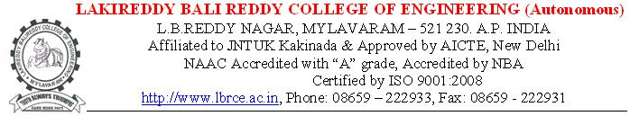

Ref: Advt./LBRCE/Faculty/2016/03 Dated 19-10-2016 in HINDU

Photo

Application for the Post of

Department

Name |  | Address for Correspondence
DOB |  | Phone:  Email-ID:
Sex
Marital Status
Caste/Category

Educational Qualifications:

Degree | Branch/ Specialization | College | University | Year of Admission | Year of Pass | % of marks
SSC
IPE/DIP
B.Tech
M.Tech
PhD

(Enclosures: Scanned copies of the above certificates.)
- Strike off which is/are not applicable

Experience Summary: Teaching: Industry: Research: Total:

S.No. | College | University | Post held | Duration |  | Ratified (Y/N) | Date of Ratification | Exp.  in yrs | Salary Drawn
 |  |  |  | From | To
1
2
3
4
(Encl: Scanned copies of experience, salary certificates etc.)

R&D:
Publications | Journal Publications | Conferences
 | International: National: | International: National:
Workshops/FDPs Attended: | (i) 1 Day: ( )  (ii) 2 to 5 Days: ( )  (iii) >5 Days: ( )
Research Projects sanctioned, if any
Books Published, if any
Conferences/Workshops organized
Awards, if any
Any other information

Present Salary |  | Expected Salary

I hereby declare that the information given above is true and correct to the best of my knowledge and belief. If I am selected, I agree to abide by the Rules and Regulations of the College.

Date: Signature of the Candidate

